ATM Management System



**Department of Computer Science and Engineering**

**Bangladesh University of Business and Technology**

**(BUBT)**

**Mirpur-02**

**21 March, 2022**

**ATM Management System**

A projectSubmitted to the Department of Computer Science and EngineeringBangladesh University of Business and Technology (BUBT), DhakaIn partial fulfillment of requirementsFor the Software Development 2of

Bachelor of Science

In

Computer Science and Engineering

By

Tunazzinur Rahman Kabbo (19202103268)

Md. Zobayer Hasan Nayem (19202103274)

Nayema Khatun (19202103245)

Rubaitul Jannat (19202103249)

Intake 44, Section-07

**SUPERVISED BY**

**Shovon Roy**Lecturer,  
Department of Computer Science and Engineering (CSE)  
Bangladesh University of Business and Technology (BUBT)  
Mirpur-2, Dhaka-1216, Bangladesh

**Abstract**

We hereby declare that the project entitled “**ATM Management System**” submitted in partial fulfillment by us for the degree B.Sc. Engineering in Computer Science and Engineering in the faculty of Computer Science and Engineering of Bangladesh University of Business and Technology (BUBT) under the guidance of our supervision of Shovon Roy, Lecturer, department of Computer Science and Engineering is our own work and it contains no material which has been accepted for the award to the candidates of any other disciplines expect few references which is taken from various books and authors to enrich our knowledge about the topic of our project.

Tunazzinur Rahman Kabbo

Id: 19202103268

Md. Zobayer Hasan Nayem

Id: 19202103274

Rubaiatul Jannat

Id: 19202103249

Nayema Khatun

Id: 19202103245

**Certificate**

That is to certify that Tunazzinur Rahman Kabbo, Md. Zobayer Hasan Nayem and Nayema Khatun and also Rubaiatul Jannat students of B.Sc. in CSE has completed their project work titled **“ATM Management System”** satisfactorily in partial fulfillment for the requirements of B.Sc. in Computer Science and Engineering from Bangladesh University of Business and Technology in  
the year December, 2021.

Tunazzinur Rahman Kabbo

Id: 19202103268

Md. Zobayer Hasan Nayem

Id: 19202103274

Rubaiatul Jannat

Id: 19202103249

Nayema Khatun

Id: 19202103245

**Project Supervisor**

Shovon Roy

Lecturer,

Department of CSE

Bangladesh University of Business and Technology

**DEDICATION**

Dedicated to our parents for all their love and inspiration.

**ACKNOWLEDGEMENT**

**“When a task is completed successful”** makes everyone happy. But the happiness will be gold without glitter if we didn’t state the persons who have supported us to make it a success. Success will be crowned to people who made it a reality but the people whose constant guidance and encouragement made it possible will be crowned first on the eve of success. This acknowledgment transcends the reality of formality when we would like to express deep gratitude and respect to all those people behind the screen who guided, inspired and helped me for the completion of our project work. We consider ourselves lucky enough to get such a good project. This project would add as an asset to our academic profile. We express our gratitude to the help of our supervisor **Shovon Roy**, for his constant supervision, guidance and co-operation throughout the project and for giving constant motivation and valuable help through the project work.

We extend our sincere gratitude to our parents who have encouraged us with their blessings to do this project successfully. Finally, we would like to thank to all our friends, all the teaching and non-teaching staff members of the CSE Department, for all the timely help, ideas and encouragement which helped throughout in the completion of project.

**Approval**

This project **“ATM Management System”** submitted by Tunazzinur Rahman Kabbo,  
Md. Zobayer Hasan Nayem, Nayema Khatun and Rubaiatul Jannat who belong ID No. sequentially 19202103268, 19202103274, 19202103245, 19202103249 students of B.Sc. in Computer Science and Engineering from Bangladesh University of Business and Technology  
in the year March, 2022 under the supervision of Shovon Roy, Lecturer, Department of Computer Science and Engineering has been accepted as satisfactory for the partial fulfillment for the requirements of B.Sc. in Computer Science and Engineering and approved as to its style  
and contents.

**Project Supervisor**

Shovon Roy

Lecturer,

Department of CSE

Bangladesh University of Business and Technology

**COPYRIGHT**

© Copyright by Tunazzinur Rahman Kabbo (19202103268), Md. Zobayer Hasan Nayem (19202103274), Nayema Khatun (19202103245) and Rubaiatul Jannat (19202103249).

**LIST OF FIGURES**

**LIST OF FIGURES**Figure-1 : Splash Screen ………………………………………………………………….15  
Figure-2 : Main Menu………………….………………………………………………….15  
Figure-3 : Registration…………………………………………………………………….16  
Figure-4 : Registration For Bank…..……………….……………………………………..16  
Figure-5 : Registration For Card…………………………………………………………..17  
Figure-6 : Login……………………………………………………………………………17  
Figure-7 : User Dashboard…………………………………………………………………18  
Figure-8 : User Withdraw…...……………………………………………………………..18  
Figure-9 : User Transfer…..………………………………………………………………..19  
Figure-10: User Bill Pay……………………………………………………………………19  
Figure-11: User Payment………………………..………………………………………….20  
Figure-12: User Crypto Currency…………………………………………………………..20  
Figure-13: User Add Money………………………………………………………………..21  
Figure-14: User Donation…………………………………………………………………..21  
Figure-15 :Update Pin………………………………………………………………………22

Figure-16: Update Profile…………………………………………………………………..22

**Admin Figure**

Figure-1 : Admin Captcha…………………………………………………………………23  
Figure-2 : Admin Login…………………………………………………………………...23  
Figure-3 : Admin Unblocking Splash Screen……………………………………………..24  
Figure-4 : Admin Dashboard……………………………………………………………...24  
Figure-5 : Admin Show Registration bank………………………………………………..25  
Figure-6 : Admin Show Registration Card………………………………………………..25  
Figure-7 : Admin Show Transfer History………………………………………………....26  
Figure-8 : Admin Block and Unblocking…………………………………………………26  
Figure-9 : Admin Block Card User……………………………………………………….27  
Figure-10: Admin Unblock Card User………….………………………………………...27

Figure-11: Admin Block Bank User………………………………………………………28  
Figure-12: Admin Unblock Bank User……………………………………………………28  
Figure-13: Admin Update Dollar Rate…………………………………………………….29

Figure-14: Admin Update Cryptocurrency Rate……………………………………….….29  
Figure-15: Admin Update Billing System…………………………………………………30  
Figure-16: Admin Show all Donation History….…………………………………………30  
Figure-17: Admin Show Payment History….……………………………………………..31

**Introduction………………………………………………………………...……………11**

**2. Project Review…….…………………………………………………………….…11** 2.1 Problem Statement……………………………………………………..….…11  
 2.2 Objective of this project………………………………………………….…..11  
 2.3 Feature of this project…………………………………………………….…..12

**3. Technologies….…………………………………………………………………….12** 3.1 Software……………………………………………………………....……...12  
 3.1.1 Visual studio………………………………………………………..….…12  
 3.1.2 Xampp………………………………………………….…………..…….13  
 3.1.3 mysql-connector-net-8.0.23........................................................................13  
 3.2 Programming Language.……………………………………………..…..…..13  
 3.2.1 C# Language………………………………………….……………..…....13  
 3.3 Software framework.…………………………………………………..…......13  
 3.3.1 The .NET framework………………………….…………..……………...13

**4. System Analysis ………………..…………………………...………………………14** 4.1 System user analysis……..…………………..…...…………..…………......14  
 4.1.1 Admin Panel…………………………………..………….…………..…...14  
 4.1.2 Student Panel…..…….………………………..………….…………..…...14

**5. Access System…….……….………..…………………………….……………..….15** 5.1 User Panel……….………………………………….….…………..….……15  
 5.2 Admin Panel…..…….…………………………….…….……………..…....23

**6. Diagram…………………………………..………………………….…………….32** 6.1 schema diagram......................................................................................32  
 6.2 ER Diagram ...........................................................................................33

**7. Future work ...........................................................................................................34**

**8. Conclusion ..............................................................................................................34**

**9. Reference ................................................................................................................34**

1. **Introduction**

With many banks and financial institutions closing their physical doors and reducing staff levels to save costs, ATMs are becoming a vital part of the way customers transact. Even with the global shift to mobile and online banking, and predictions of an eventually cashless society, ATMs are still seen as an essential service. The convenience of an ATM allows consumers to perform quick self-service transactions like depositing and withdrawing cash, bill payment and transfers between accounts.

However, with massive advances in software and hardware, an ATM is not just for depositing and withdrawing. Today's ATMs are more complex and multi-dimensional. Often, they use software and hardware from various vendors and communicate with different services, and more than one network, providing a broader range of transactions.

1. **Project Review**
   1. **Problem Statement**

We developed a software that why people are easily using his payment system. They can easily deposit his money, transfer his money, also he can buy cryptocurrency, he can easily exchange BDT to USD. he can check daily Cryptocurrency Rate.

**2.2 Objective of the Project**

We were looking for a project to select that didn’t match the other groups. The **“ATM Management System”** got the idea while searching for the project in internet. There we saw a lot of complete projects but they were in another high-level language. There were no such projects using C# language. And then we decided that we would complete this project using C# language. By the end of this project, the basics in C# language have become clearer. The mentality of developing software and working in a team has been created. By completing the project, we learned some of the functions of C# language that were unknown to us.

2.3 **Features of Project**

1. Splash Screen.

2. Main Menu.

3. Easy Bank account Registration.

4. Easy Card account Registration.

5. Registration Bonus 500 BDT.

6. Easy use this system

7. Responsive User Design

8. Easy Transaction System

9. Easy Exchange BDT To USD.

10. Easy Buy Cryptocurrency

11. Responsive Admin Panel.

**3.Technology**

**3.1 Software**

**3.1.1 Visual Studio Community**

Visual Studio is an Integrated Development Environment (IDE) developed by Microsoft to develop GUI (Graphical User Interface), console, Web applications, web apps, mobile apps, cloud, and web services, etc. With the help of this IDE, you can create managed code as well as native code. It uses the various platforms of Microsoft software development software like Windows store, Microsoft Silverlight, and Windows API, etc. It is not a language-specific IDE as you can use this to write code in C#, C++, VB(Visual Basic), Python, JavaScript, and many more languages. It provides support for 36 different programming languages. It is available for Windows as well as for macOS.

**3.1.2 Xampp**

XAMPP is a cross-platform web server that is free and open-source. XAMPP is a short form for Cross-Platform, Apache, MySQL, PHP, and Perl. XAMPP is a popular cross-platform web server that allows programmers to write and test their code on a local webserver. It was created by Apache Friends, and the public can revise or modify its native source code. It includes MariaDB, Apache HTTP Server, and interpreters for PHP and Perl, among other computer languages. Because of XAMPP’s simplicity of deployment, a developer can quickly and easily install a WAMP or LAMP stack on an operating system, with the added benefit that common add-in apps like WordPress and Joomla can also be loaded.

**3.1.3 mysql-connector-net-8.0.2**

MySQL Connector/NET 8.0.23 is the latest General Availability release of the MySQL Connector/NET 8.0 series. This version supports .NET 5.0 and the X Dev API, which enables application developers to write code that combines the strengths of the relational and document models using a modern, NoSQL-like syntax that does not assume previous experience writing traditional SQL.

**3.2 Programming Language**

**3.2.1 C# Language**

C# (pronounced "See Sharp") is a modern, object-oriented, and type-safe programming language. C# enables developers to build many types of secure and robust applications that run in .NET. C# has its roots in the C family of languages and will be immediately familiar to C, C++, Java, and JavaScript programmers. This tour provides an overview of the major  
components of the language in C# 8 and earlier. If you want to explore the language through interactive examples, try the introduction to C# tutorials. C# is an object-oriented, ***component-oriented*** programming language. C# provides language constructs to directly support these concepts, making C# a natural language in which to create and use software components.  
Since its origin, C# has added features to support new workloads and emerging software design practices. At its core, C# is an ***object-oriented*** language. You define types and their behavior.

**3.3.** **Software framework**

**3.3.1 The .NET Frame Work**

.NET is a framework to develop software applications. It is designed and developed by Microsoft and the first beta version released in 2000. It is used to develop applications for web, Windows, phone. Moreover, it provides a broad range of functionalities and support. This framework contains a large number of class libraries known as Framework Class Library (FCL). The software programs written in .NET are executed in the execution environment, which is called CLR (Common Language Runtime). These are the core and essential parts of the .NET framework. This framework provides various services like memory management, networking, security, memory management, and type-safety.

**4. System Analysis**

**4.1 System user analysis**

**4.1.1 Admin Panel**

ADMIN In the admin panel, the admin can log in to the software using a special username & password. From the admin panel, an admin can view all data, insert any data, change/update any data, and also can delete any data from the database.

**4.1.2 User Panel**

In the user panel, the user has to register with some personal Information and then he/she can login to the software using the Username and password. Then he/she can only view his/her needed Data.

**5. Access System**

**1. Splash Screen**

Before starting the software, an animated splash screen will be shown. It will make sense about ATM Management System.

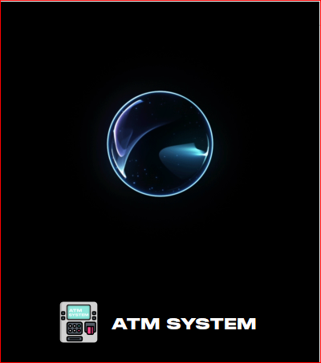

Figure: 1. Splash Screen

**2.Main Menu**

From the main menu, the user and the admin both of them will register, show credit, go admin panel and also could login

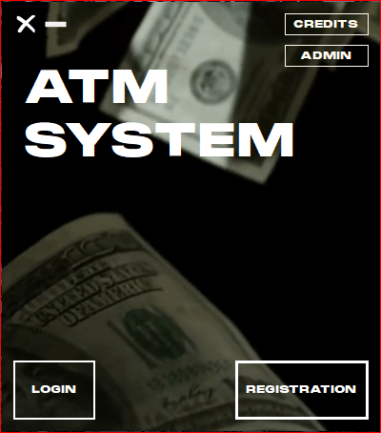

Figure :02 Main Menu

**3.Registration**

From the registration page, the admin and the user could create an account (bank acc or card) to give some personal information. Besides for backup, admin will show the whole info from the saved file in Database. After creating an account user will get 500 BDT in his/her account automatically.

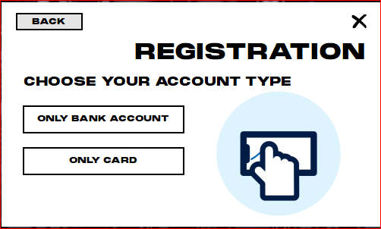

Figure :03 Registration

**4. Registration Bank Account**

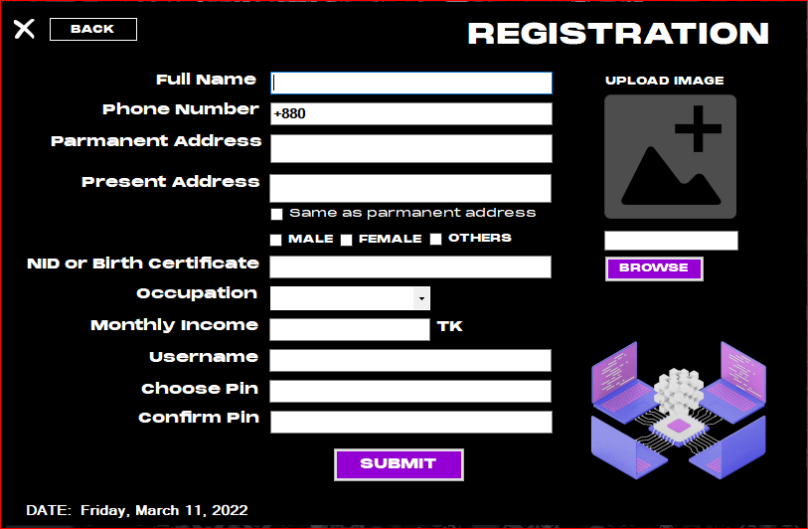From the registration page, the admin and the user could create a bank account to give some personal information. Besides for backup, admin will show the whole info from the saved file in Database.

Figure :04 Registration Bank account

**5. Registration Card Account**

From the registration page, the admin and the user could create a card account to give some personal information. Besides for backup, admin will show the whole info from the saved file in Database.

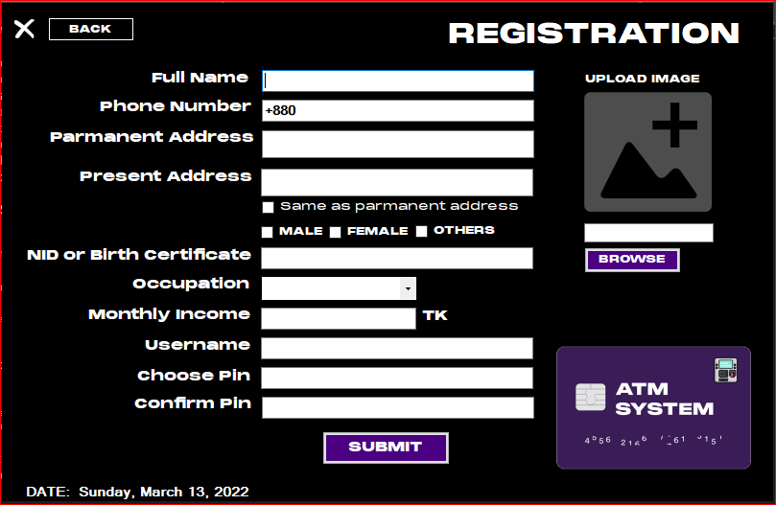

Figure :05 Registration Card account

**6. Login**

From the registration page anyone will get a button for login. Only they could login who have registered before.

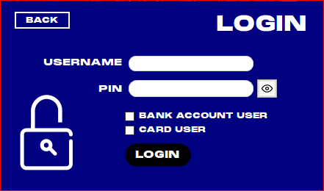

Figure :06 Login

**7. User Dashboard**

After login as user, you will get these options(withdraw, transfer, bill pay, payment, crypto currency, add money, fast loan, donation, update profile).

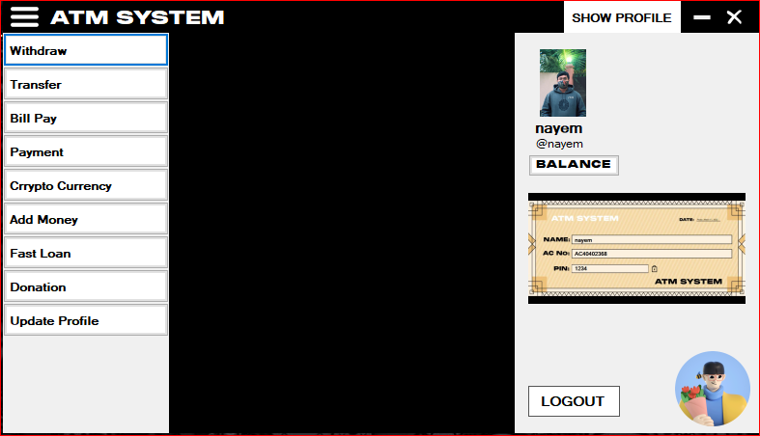

Figure :07 User Dashboard

**8. Withdraw**

Users could withdraw any amount of currency when they want. But if they do have not a sufficient amount then he/she will get an alert message and could not transact.

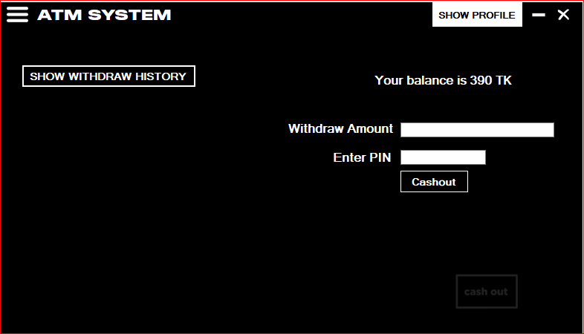

Figure :08 Withdraw

**9. User Transferer**

The User could transfer at any time the valid currency to any type of account

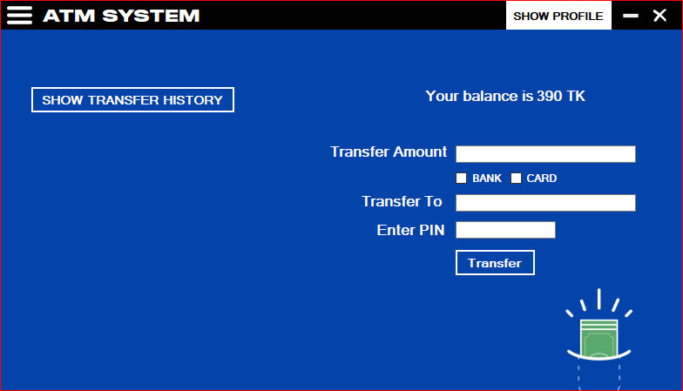

Figure :09 User Transferer

**10. Bill Pay**

The user will pay any type of bill from here. Such as University bills, shopping bills, current bills, restaurant bills, etc.

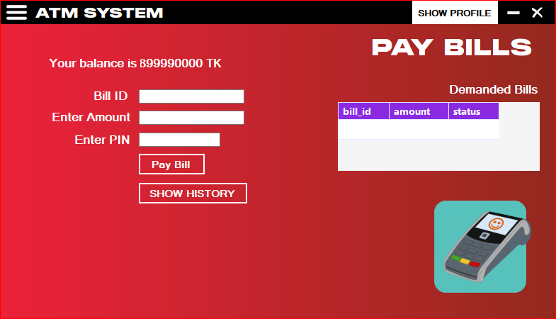

Figure: 10 Bill Pay

**11. Payment**

The user will pay any type of payment from here. Such as salary, University bills, shopping bills, current bills, restaurant bills, any ticket bills, etc.

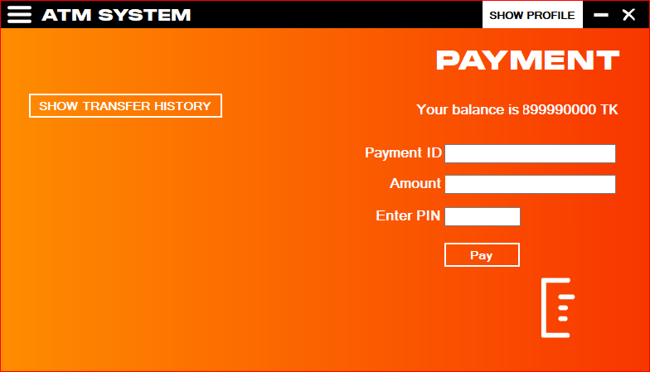

Figure:11 Payment

**12. Cryptocurrency**

The user could exchange cryptocurrency. The user will show the currency, transfer the currency and also buy and sell the currency from this software.

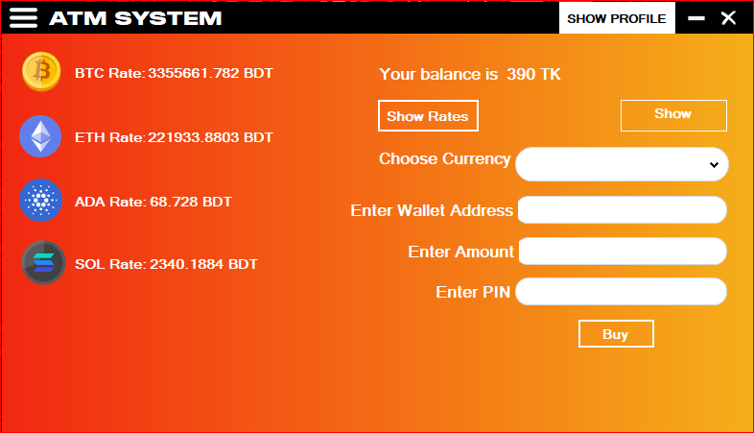

Figure: 12. Cryptocurrency

**12. Add Money**

The user could add money to his/her account from all types of accounts there are Bikash, Nogod, Rocket, Upay, Mastercard by this software.

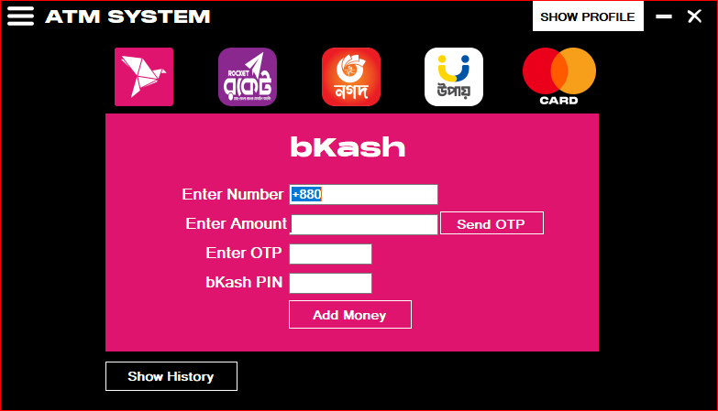

Figure: 12. Add Money

**14. Donation**

Making a donation through Charity ATM is quick and easy. Consumers have the option of donating to a number of charities at participating ATM locations.

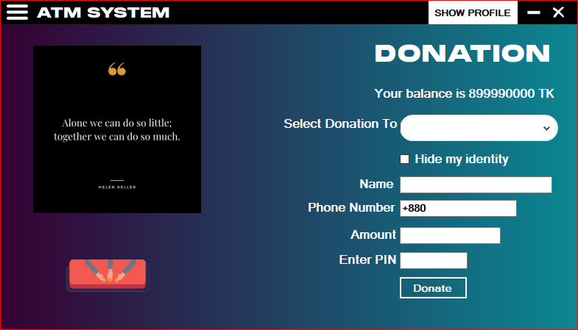

Figure: 14. Donation

**15. Update Profile (Change Pin)**

User can also update his/her profile. He can also change Pin and his user information.

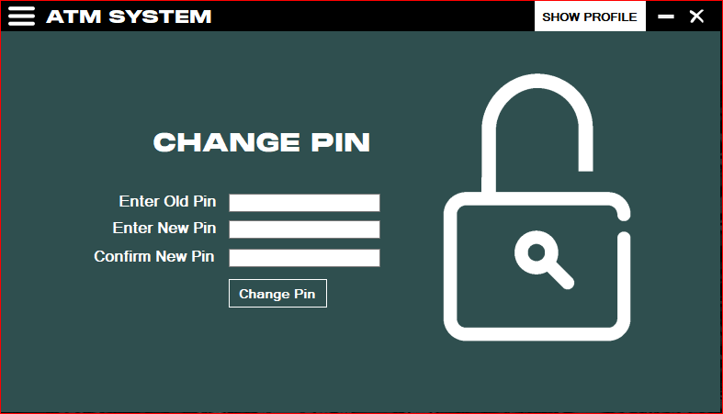

Figure: 15. Update Profile (change Pin)

**15. Update Profile (Update Profile)**

User can also update his/her profile. He can also change Pin and his user information.

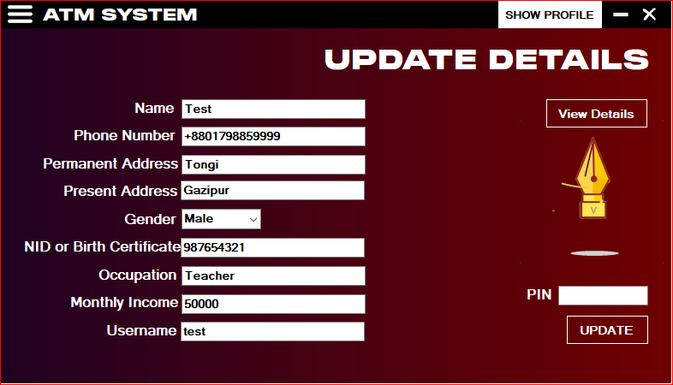

Figure: 15. Update Profile (change Pin)

**6. Admin**

**1. Admin Captcha**

When anyone register as admin, he/she will face this Captcha.

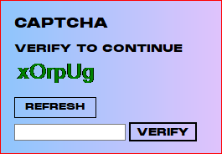

Figure: 1. Admin Captcha

**2. Admin Login**

After registration admin can login with appropriate Id and Pin and also go back if need.

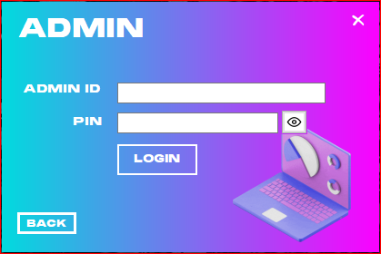

Figure: 2. Admin Login

**3.Admin Unlocking Splash Screen**

When admin give all data correctly then he will get this page and go to admin dashboard.



Figure: 3. Admin Unlocking Splash Screen

**4.Admin Dashboard**

Admin reach the admin dashboard he will get all options and saw a responsive user interface.

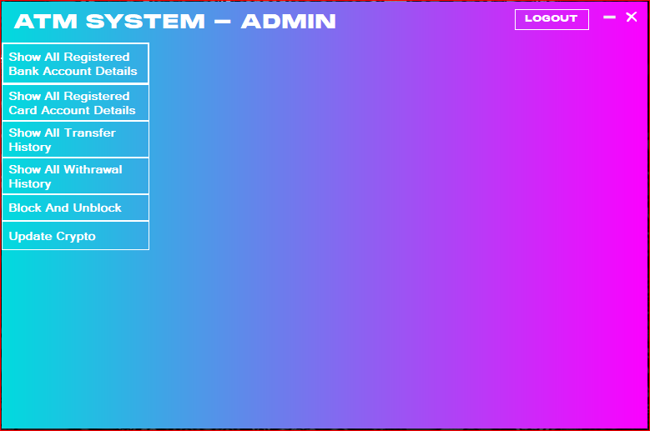

Figure: 4. Admin Dashboard

**5. Admin Show Registration Bank Account**

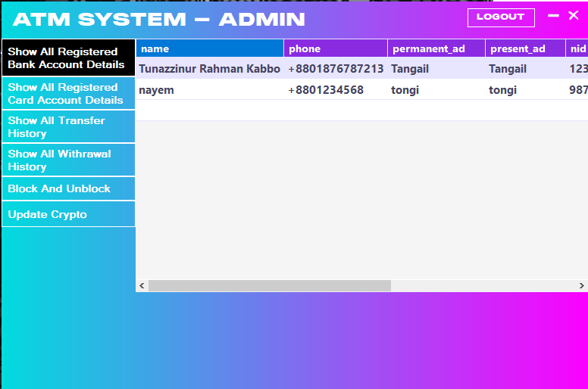If admin want to see the details of all bank accounts he will see easily from this dashboard.

Figure: 5. Admin Show Registered Bank

**6. Admin Show Registered Card**

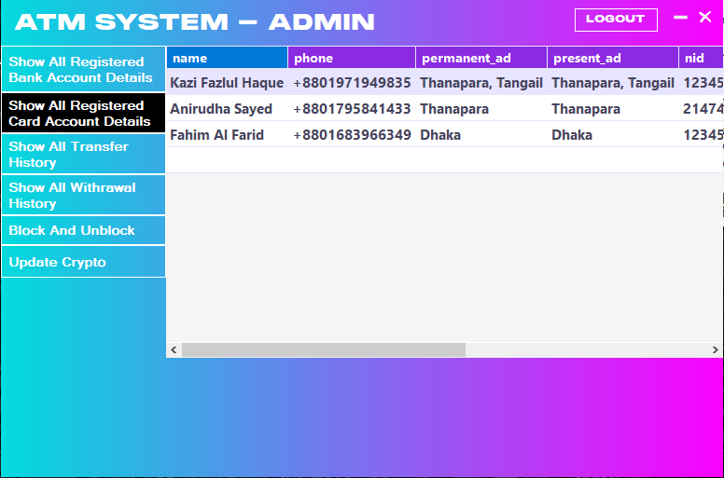If admin want to see the details of all card account he will see easily from this dashboard.

Figure: 6. Admin Show Registered Card

**7. Admin Show Transfer History**

If admin want to see the history of money transfer of all bank and card accounts he will see easily from this dashboard.

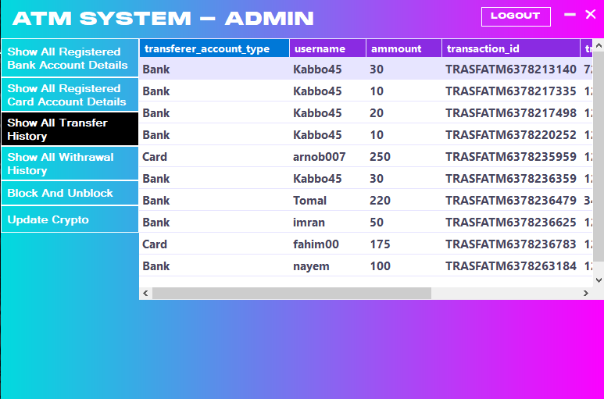

Figure: 7. Admin Show Transfer History

**8. Admin Block and Unblocking**

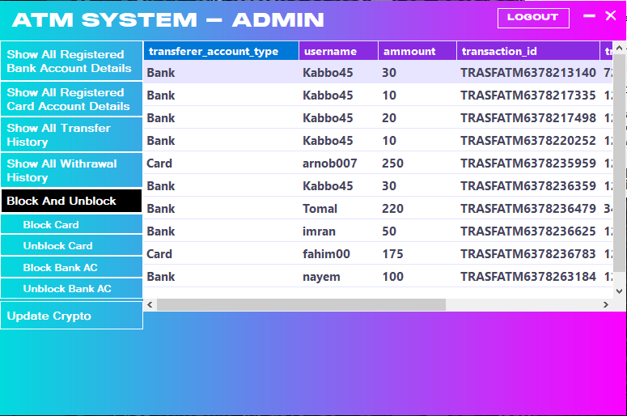Admin can block any kind of bank and card account users and unblocking any account.

Figure: 8. Admin Block and Unblocking

**9. Admin Block Card User:**

Admin can block any kind of card account users and unblocking any account.

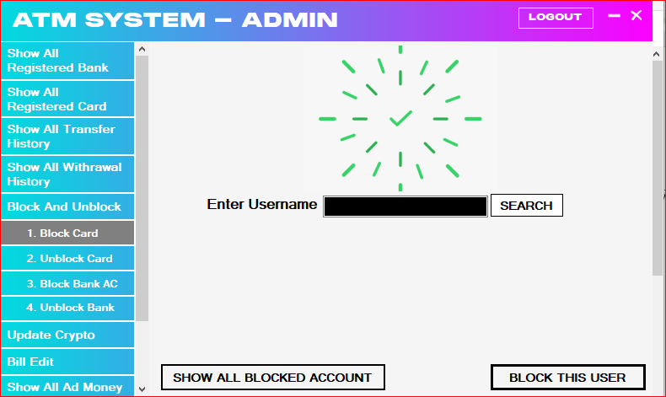

Figure:9. Block Card

**10. Admin Un-block Card User:**

Admin can unblock any kind of card account users and unblocking any account.

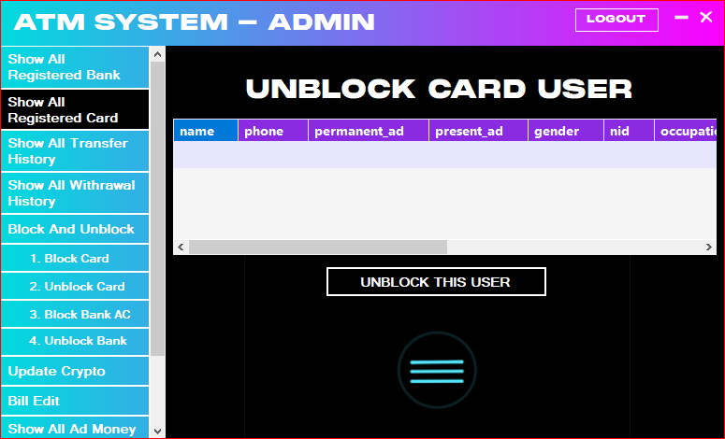

Figure: 10: Un-block Card

**11. Admin Block Bank User:**

Admin can block any kind of card account users and unblocking any account.

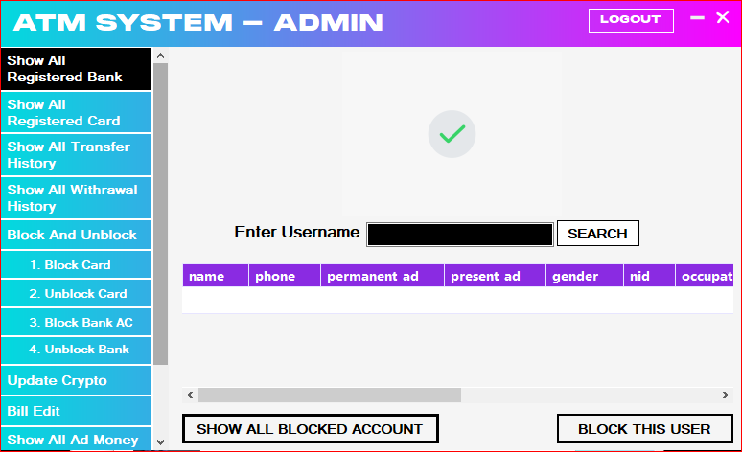

Figure: 11: Block Bank User

**12. Admin Un-block Bank User:**

Admin can unblock any kind of card account users and unblocking any account.

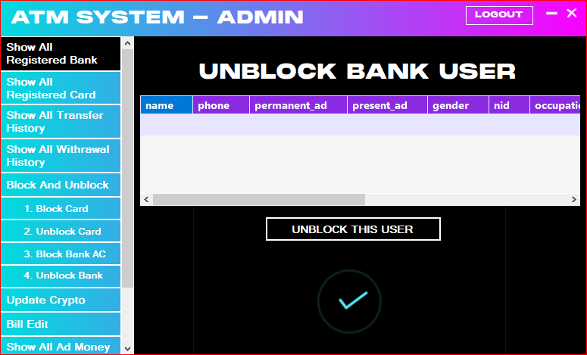

Figure: 12: Un-block Bank User

**13. Admin Update Dollar Rate**

Admin can update any currency rate as dollar.

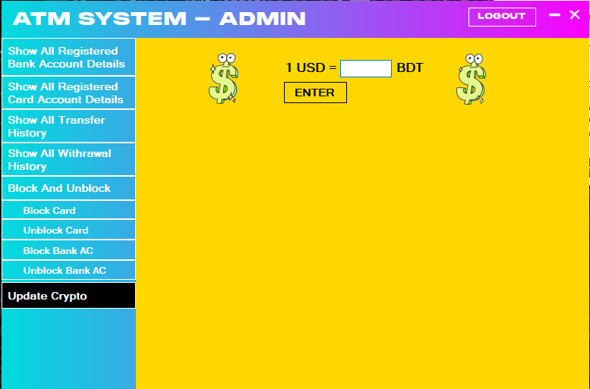

Figure: 13. Admin Update Dollar Rate

**14. Admin Update Cryptocurrency Rate**

Admin can update any Cryptocurrency rate as Bitcoin, ETH, ADA, SOL.

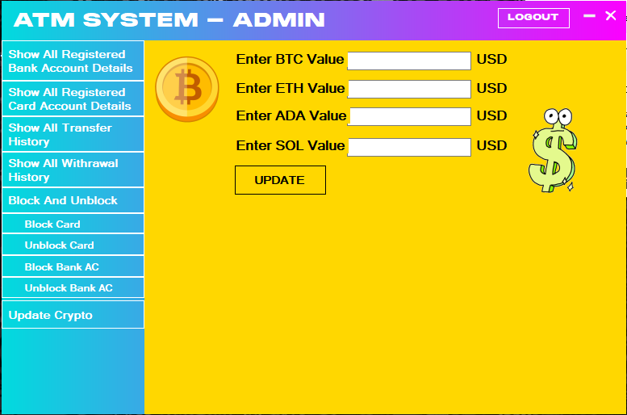

Figure: 14. Admin Update Cryptocurrency Rate

**15. Admin Billing System:**

Admin can create Billing for user.

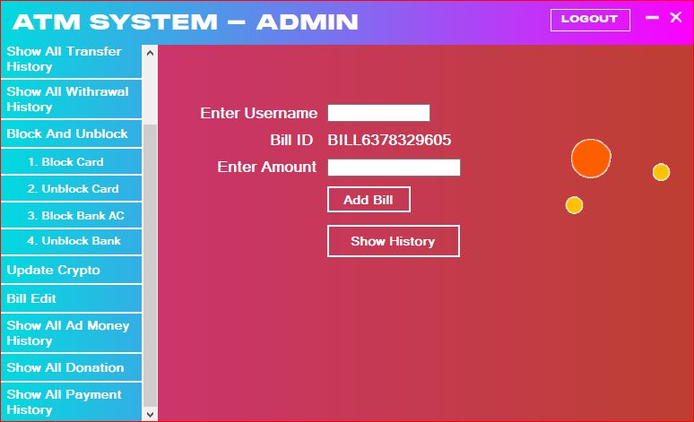

Figure:15. Admin Billing System

**16. Admin Show all Donation History:**

If admin want to see the details of all Donation History he will see easily from this dashboard

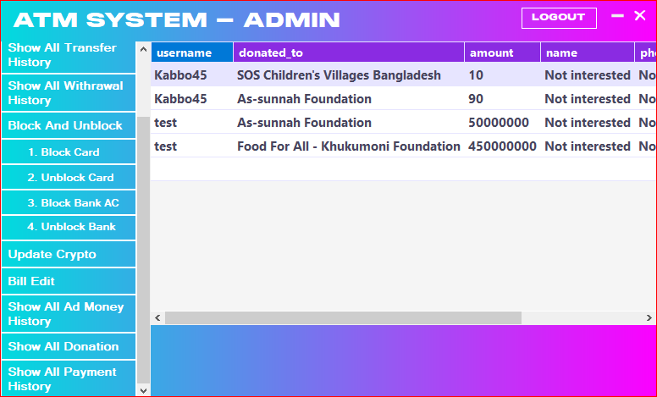

Figure:16. Admin Show all Donation System

**17. Admin Show Payment History:**

If admin want to see the details of all Payments history he will see easily from this dashboard**.**

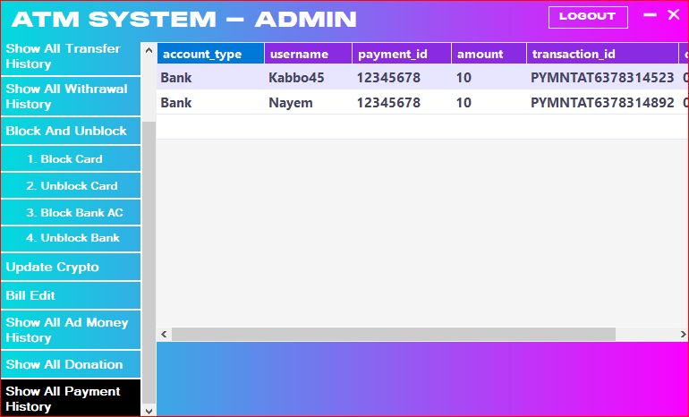

Figure:17. Admin Show all Donation System

**Schema Diagram**

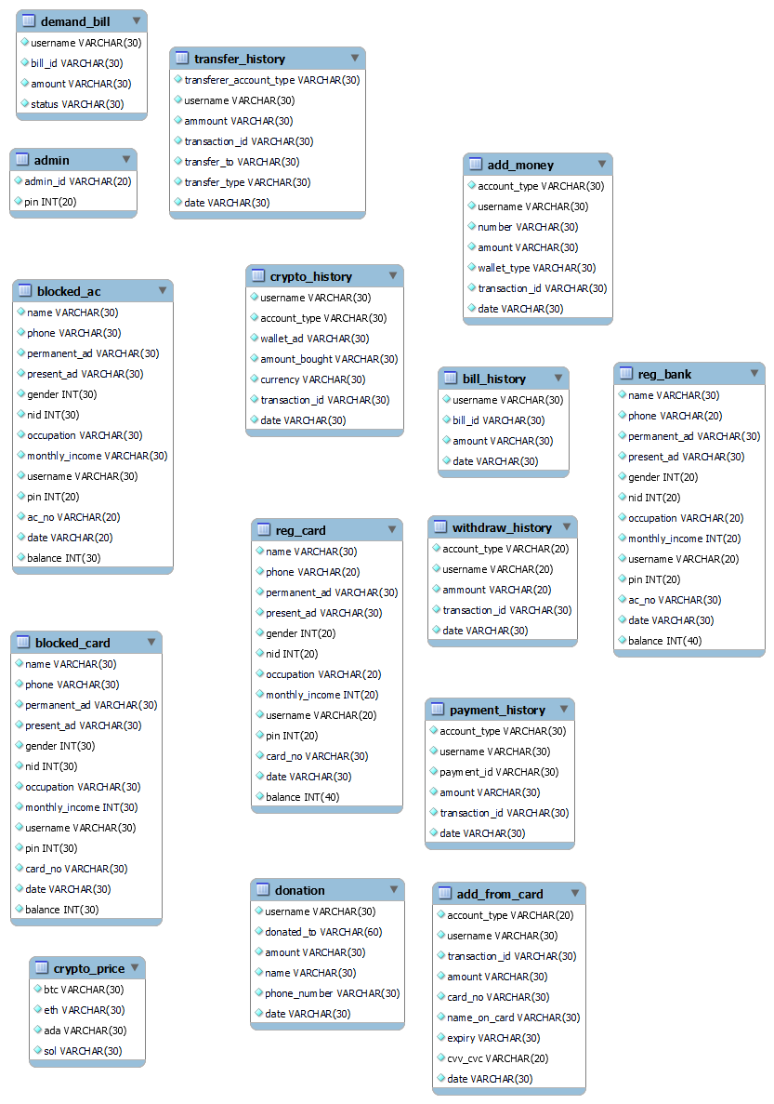

**ER Diagram**

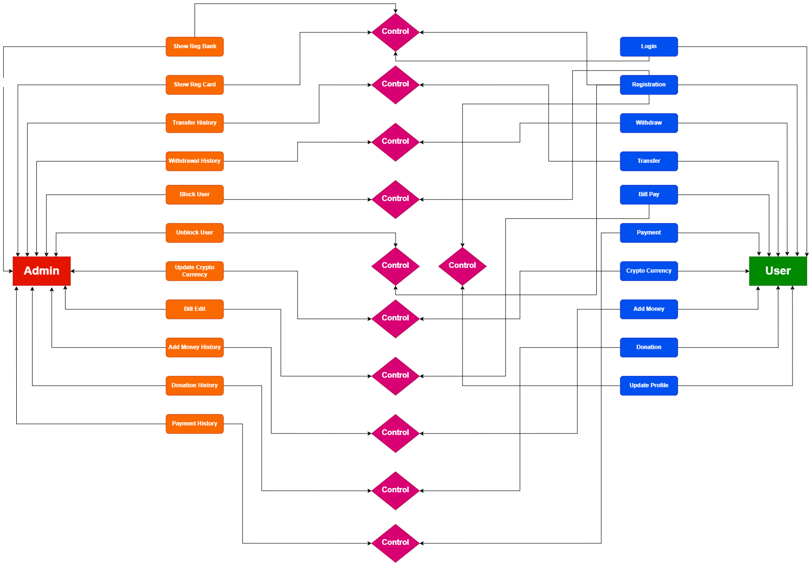

**7. Future Work**

1. We want to make this software more user friendly.  
2. We will an option for reporting bugs for fixing bugs (if any) or  
suggestions for better support.  
3. We will add an option as “International Transfer System” for students if BUBT  
Authority allows us.

**8. Conclusion**

We started this project when we had very few concepts about the C# language and its different usage. During the project preparation we were introduced with the new concepts and new elements of C# language along with the progression of the course. We were able to apply all those theoretical C# concepts taught to us in our application to make it more and more functional. Over time, we've worked to make our project more compact and more user-friendly. During this period, we learned various C# programming concepts and now in position to design in the error free program successfully. Overall, the team feels that the project is pretty successful although we did face a few problems here and there but we came to know the various C# programming techniques. We learned to make the variables and constants either global or local. Then we also learned the practical way of implementing the structures in the program and access the members of structures, compare them, initialize them and so on. The implementation of techniques like string comparison, function calling, recursion, array storage, using file for storage, and calling by value or reference has broaden my knowledge regarding C# language.

**9. Reference**

1. **Stack Overflow**
2. **GitHub**
3. **W3School**